BEA - On Demand ECL - Design Document

ERS Banking RegTech

Exported on Sep 13, 2019

Table of Contents

1 Summary 4

2 Functional Flows 5

3 Instrument Coverage 6

4 Facility Drawdown Model 7

5 User Interface Design 8

6 Reporting Date Selection 17

7 Data Retention 18

8 Inputs 19

8.1 Borrower 19

8.2 Exposure 19

8.2.1 Loandepo 19

8.2.2 Facility 19

8.2.3 Security Position 19

8.2.4 Repo 19

8.2.5 Stage Details 19

8.2.6 Imported Cashflows 19

8.3 CRM 19

9 Curve Lookup 20

9.1 Discount Curve Lookup 20

9.2 Reference Curve Lookup 21

10 Results 23

10.1 Scenario Weighting Logic 23

11 User Access Management 24

11.1 Collateral and BU Department Code 24

* Summary
* Functional Flows
* Instrument Coverage
* Facility Drawdown Model
* User Interface Design
* Reporting Date Selection
* Data Retention
* Inputs
  + Borrower
  + Exposure
    - Loandepo
    - Facility
    - Security Position
    - Repo
    - Stage Details
    - Imported Cashflows
  + CRM
* Curve Lookup
  + Discount Curve Lookup
  + Reference Curve Lookup
* Results
  + Scenario Weighting Logic
* User Access Management
  + Collateral and BU Department Code

# Summary

Moody's Analytics implemented RiskConfidence (RCO) and RiskFoundation (RFO) at BEA to compute expected credit loss (ECL) based on IFRS9 accounting rules on a monthly basis.

In addition to the monthly process, BEA is looking for a software solution to compute ECL of a credit proposal on demand in pro-forma basis. The computation should leverage the existing RCO + RFO based IFRS9 infrastructure where possible.

The purpose of document is to explain the design of the of the on-demand ECL solution.

# Functional Flows

At a high level, the user flow will be as follows:

Borrower selection

* Search for an existing borrower
* Select the existing borrower or create a new borrower
* For existing borrower, change borrower characteristics such as rating

Exposures

* Load existing exposures for a borrower (only for existing borrower)
* Enter simulated exposures for a borrower
* Enter imported cashflows for an exposure (existing or new exposure)
* Enter stages for a loan exposure

CRM

* Load existing CRM for a borrower (only for existing borrower)
* Load existing CRM allocation for a borrower (only for existing borrower)
* Enter new CRM for a borrower
* Run auto CRM allocation based on existing rules and processes defined in RFO
* Manually change CRM allocation amount for each exposure ↔ CRM pair

Simulation

* Enter remarks and submit a simulation
* See results of a simulation
* Export results of a simulated to CSV and PDF
* Delete results of a simulation
* Reload the simulation

# Instrument Coverage

Following type of exposures will be covered in the simulation:

* Loans (LOANDEPO table in RFO)
* Facilities (FACILITY table in RFO)
* Security positions (SECURITY_POSITION and SECURITY tables in RFO)
* Repo (REPO table in RFO).

Collateral and Guaratees: COLLATERAL, GUARANTEE and CONTRACT_GUARANTEE.

# Facility Drawdown Model

Currently, BEA applies a simple model of 100% utilization on all the facilities, based on COA account name.

The simulated facilities should get the same model applied in ECL computation.

In order to achieve that, the existing parameter deal mapping will need to be slightly modified, so that the facility utilization model is applied based on table name, instead of COA acccount name.

# User Interface Design

Once user logs in to the real-time ECL tool, they can see the list of simulations they ran.

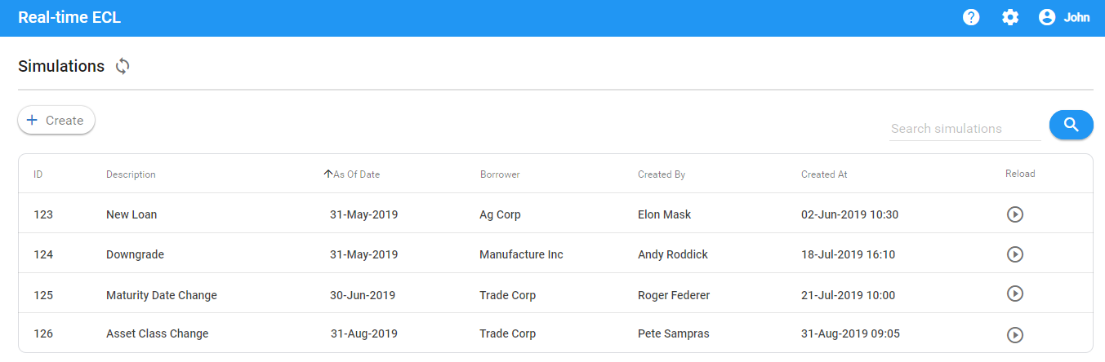

On this screen they can either create a new simulation from scratch or reload an existing simulation they ran before and reload it as a template.

Clicking on "Create" will bring a dialog to the user to enter the simulation description and select the as-of date.

As-of date is going to be defaulted to the latest one available in RFO. User can change to a past as-of date if needed.

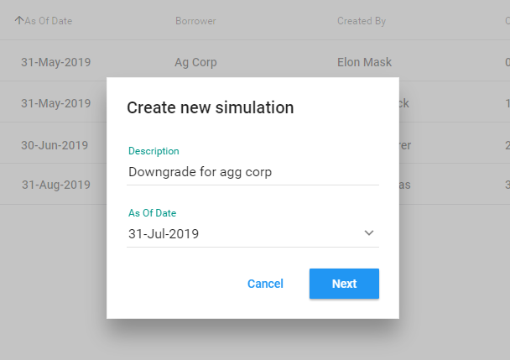

Clicking on Next will bring the Borrower search screen.

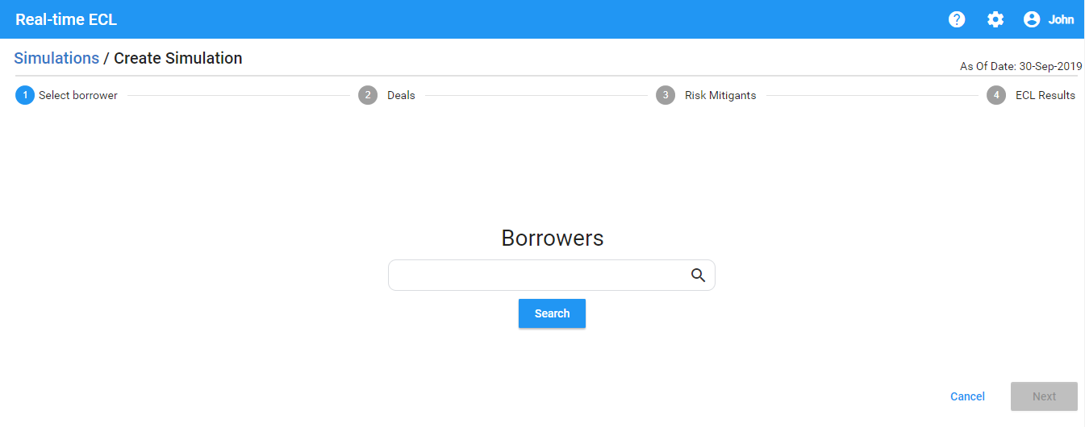

On this screen, user can enter keywords and list of borrowers will be listed.

The keywords will be matched against the following borrower fields:

* Borrower name 1
* Borrower name 2
* Borrower ID
* CI Account Number
  + One borrower may have multiple CI Account Numbers. If the search matches at least one of the CI account numbers associated with the borrower, the borrower row will be shown.
  + Simulation always runs on borrower and not CI Account level.
  + If user is creating a new borrower, the CI Account Number will be empty

Once user hits the Search, the tool will bring the list of existing and simulated borrowers.

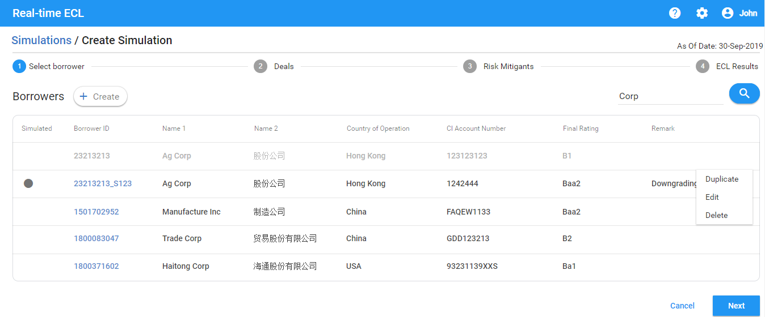

On this screen, user can do one of the following actions:

* Duplicate an existing or simulated borrower:
  + A dialog is shown to the user with all the borrower details.
  + User can change the attributes of the borrower and save.
  + Once saved, a new simulated borrower will be created with the values that the user edited.
  + The simulated entity will have a marker indicating that it is simulated

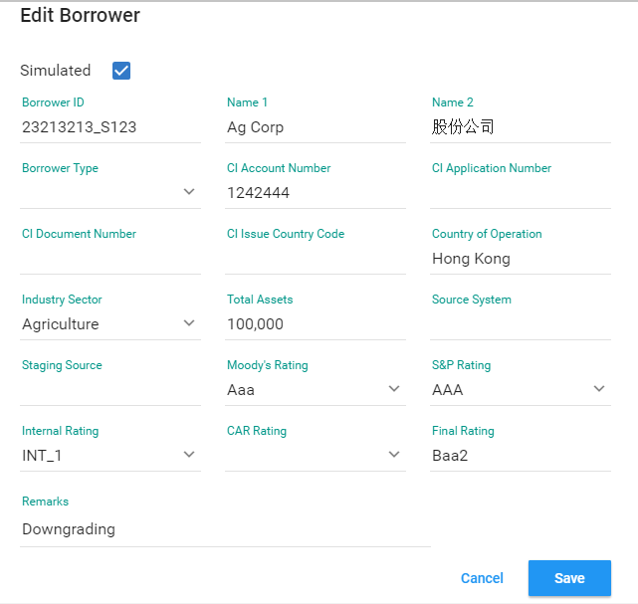

* Edit an existing borrower:
  + When user edits an existing borrower, the existing borrower is going to be grayed out and a new simulated borrower will be created with the values that the user edited.
  + The simulated entity will have a marker indicating that it is simulated
  + When user edits a simulated borrower, the values of the simulated borrower is overwritten
* Create a new borrower from scratch:
  + User will be given a dialog with list of all fields
  + User can fill each field
* Delete
  + User will have the option to delete a simulated borrower (existing borrowers cannot be deleted)

Selecting an entity and clicking on Next will bring the list of exposures associated with the borrower.

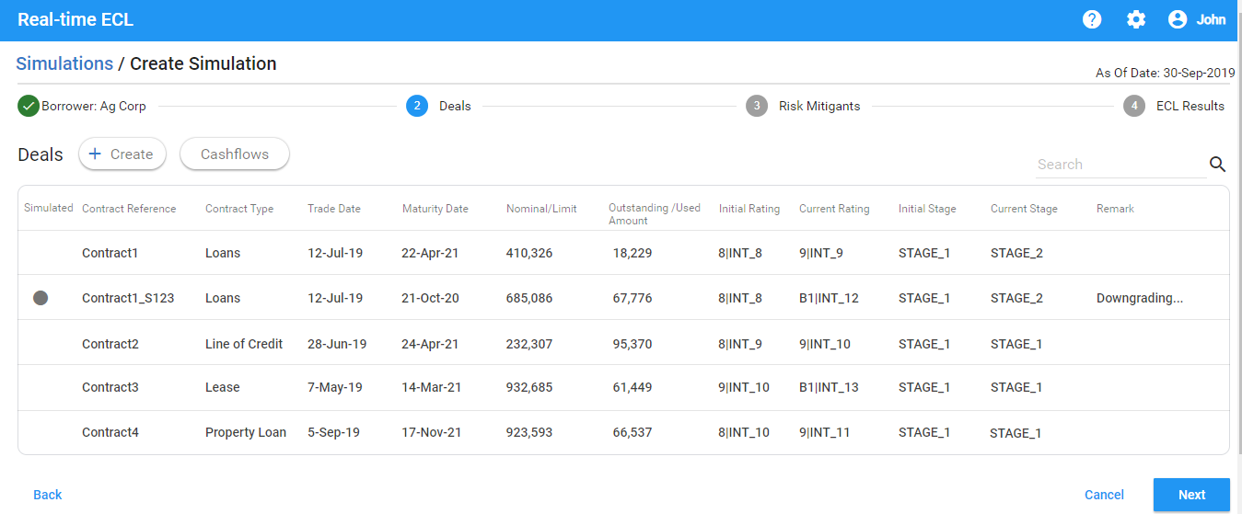

If this is an existing borrower, then the existing exposures associated with the borrower will be shown on this screen.

For any new simulated borrower this screen will be empty.

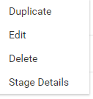

User can perform following actions on this screen:

* Duplicate an existing or simulated exposure
* Edit an existing or simulated exposure
  + Editing an existing exposure will create a copy of the exposure with the updated fields
  + Editing a simulated exposure will save the changes to the simulated exposure
* Delete a simulated exposure
* Create a simulated exposure from scratch
* Enter / edit stage details for a simulated exposure
* Enter / edit imported cashflows for a simulated exposure (loandepo and security only)

If user is creating a new simulated exposure from scratch, then user will be given a dialog to select:

* Instrument type
* A given template from the list of templates available matching the Instrument type
* A form of fields with the values coming from the template pre-repopulated

User selects the instrument type.

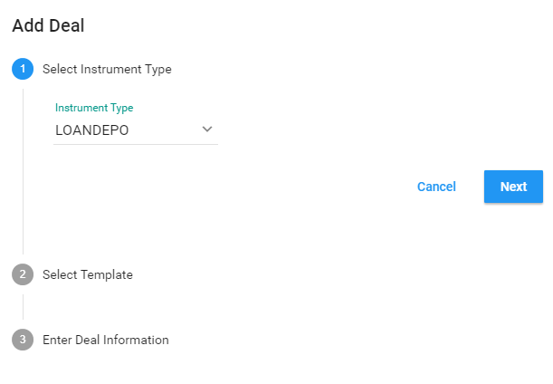

User selects a template.

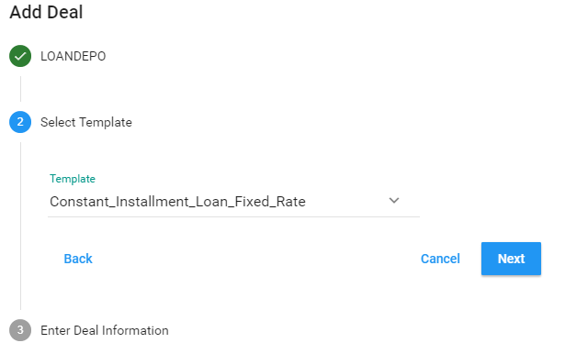

User updates / enters the deal characteristics.

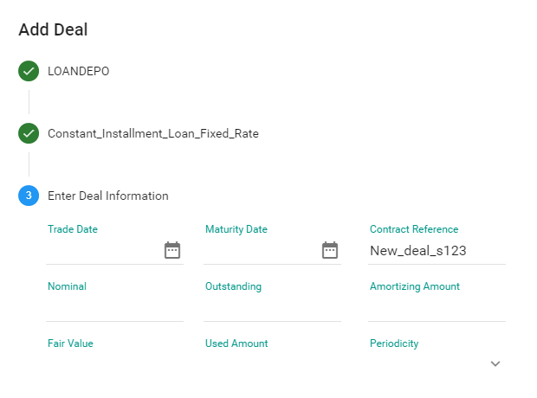

User clients on Save.

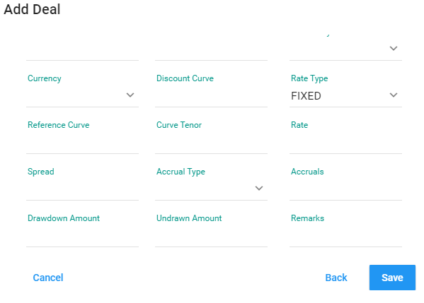

Once the user clicks Save, the new simulated exposure will be stored.

For a given simulated exposure, stage details can be edited (loandepo only).

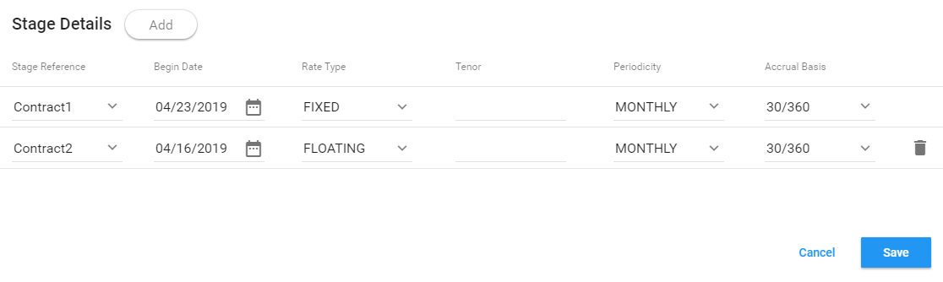

Also, for simulated exposures, user can enter imported cashflows (loandepo and security only).

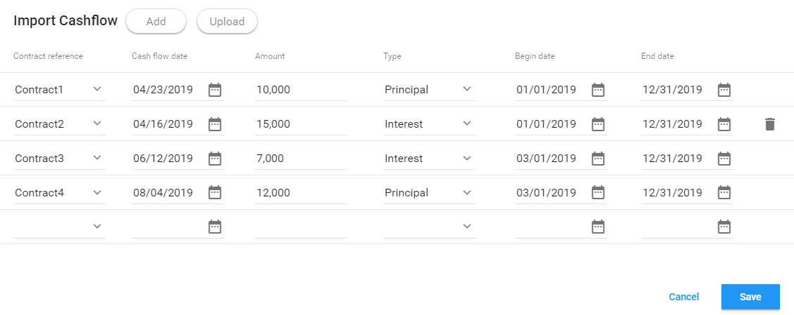

User has the option to add imported cashflows manually or upload in CSV format.

Once user saves the deal, Current Rating and Current Stage is computed and updated on the UI.



User has the ability to search deals by entering the keywords.

The keywords they entered will be checked against the deal attributes shown on the UI.

Once user finalizes the deal entry, user clicks Next. Tool takes the user to CRM allocation screen.

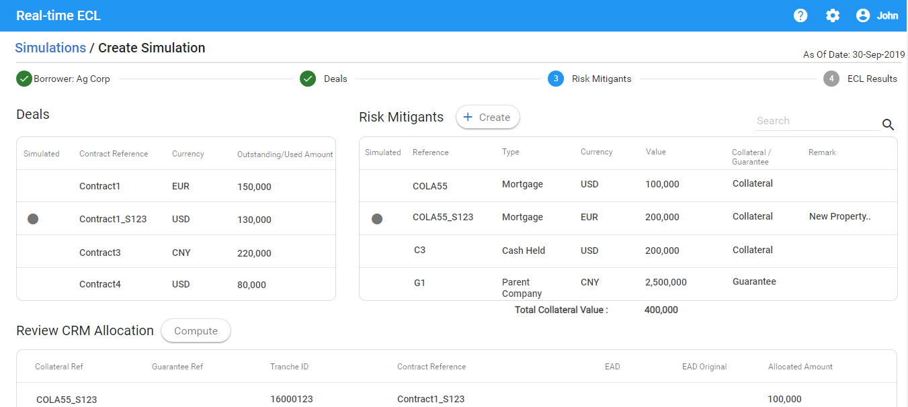

All amounts on this screen is shown in HKD.

On this screen user can:

* View list of exposures (existing and simulated exposures entered earlier)
* View List of CRMs (existing and simulated)
* Enter a simulated CRM
* View list of existing and simulated CRM Allocation
* Enter a simulated CRM Allocation

User can add a Collateral or Guarantee by clicking on Create on Risk Mitigants panel.

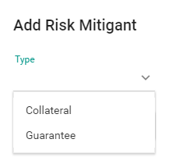

For Collateral, user then defines the fields.

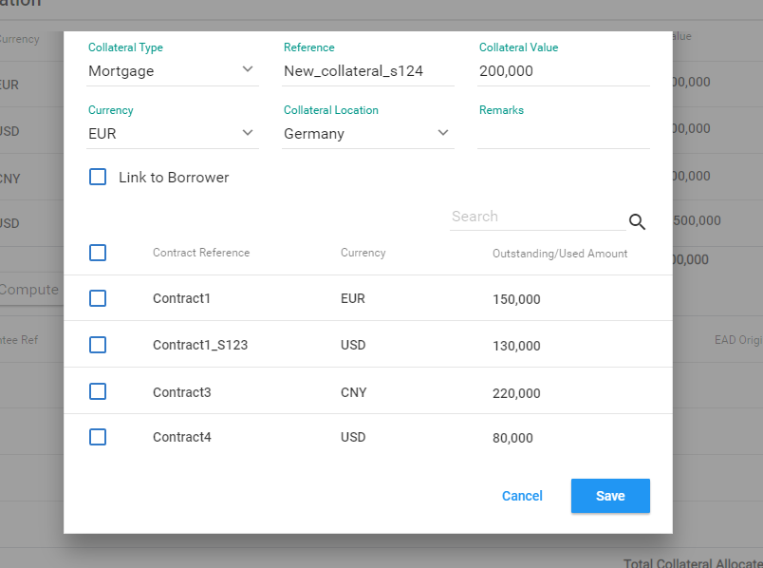

For Guarantee, user can define the fields.

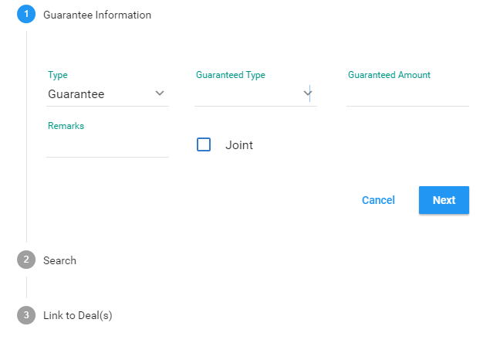

User will enter the CRM value in the native currency amount. Once the CRM is saved, the amount will be shown in HKD to the user in CRM summary screen.

For each Collateral, user will have an option to associate it at borrower level or individual deal level (but not both).

For Guarantees, user will have an option to associate it at individual deal level.

If no association is entered, collateral and guarantee will be distributed to the basket of deals in a prorata basis.

For Guarantees, user will have an option to define:

* Joint Guarantee: In this case, each guarantor will cover 100%
* Non-joint Guarantee: In this case, each guarantor will cover a portion (%) of the exposure.

Once the CRM is defined, user can click on Compute bottom. This will allocate CRM to the exposures and user can view the allocation.

After CRM allocation is done, user has the option to change the allocated amount for each CRM allocation.

System will automatically compute the total collateral amount, allocated collateral amount and remaining (unallocated) collateral amount and show on the UI.

Once CRM entry and allocation is complete user can start the simulation.

Once the simulation is done, ECL results can be viewed.

If an exposure already exists in RFO, the results from the month end is pulled to compute:

* Initial Stage
* Initial ECL
* ECL Delta

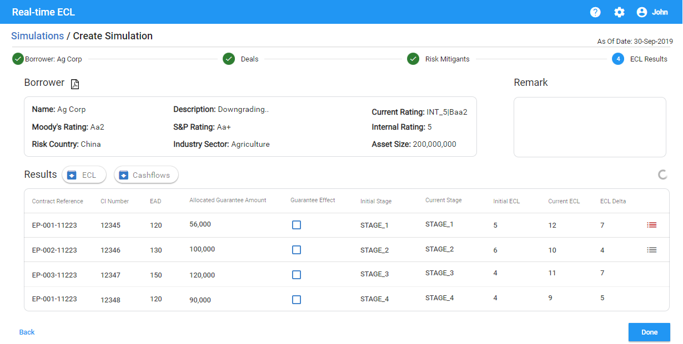

User can export the results to CSV or PDF.

User can also export the credit loss cashflows.

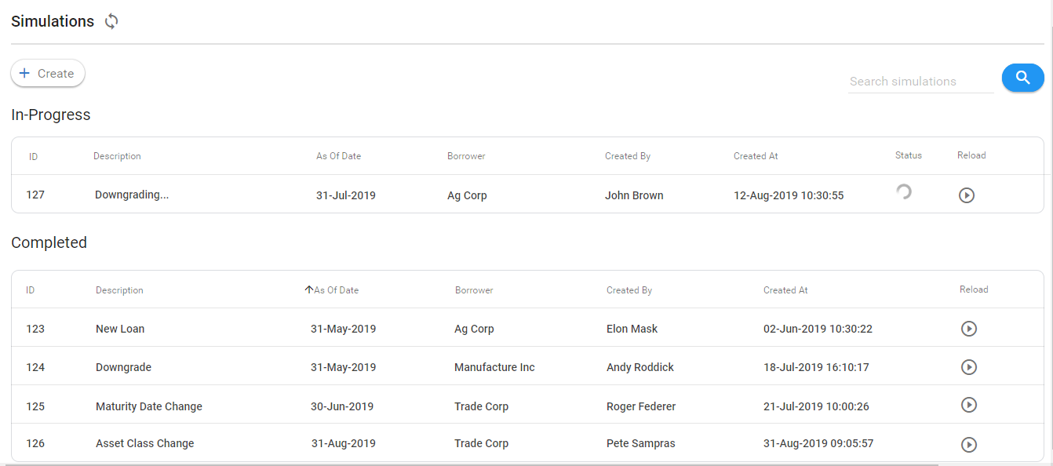

# Reporting Date Selection

The tool will automatically select the latest reporting date available for the simulation.

User can change it to a previous reporting date.

# Data Retention

Simulations results will only be available in the reporting date where they are produced.

Same rule applies to simulated borrowers, exposures, CRMs and CRM allocations created by the user.

# Inputs

## Borrower

## Exposure

### Loandepo

[LOANDEPO Fields](https://erswiki.analytics.moodys.net/display/BRT/LOANDEPO+Fields)

### Facility

[FACILITY Fields](https://erswiki.analytics.moodys.net/display/BRT/FACILITY+Fields)

### Security Position

[SECURITY_POSITION Fields](https://erswiki.analytics.moodys.net/display/BRT/SECURITY_POSITION+Fields)

### Repo

In line with the existing design, user should enter collateral against the repo deal. The security entered as part of deal characteristics will not be used as collateral for repo.

### Stage Details

### Imported Cashflows

## CRM

# Curve Lookup

## Discount Curve Lookup

Discount curve will be automatically assigned for the new deals based on the currency, using the lookup table below.

|  |  |
| --- | --- |
| **Currency Code** | **Discount Curve Code** |
| AED | * [Lo Yuen San, Sandy (non-empl)](https://erswiki.analytics.moodys.net/display/~LoYuenSS) do we need AED? |
| AUD | AUD-6M-BS-D |
| BHD | BHD_Z_DISCOUNT |
| BND | BND-SWAP |
| BRL | BRL-SWAP |
| CAD | CAD-3M-BS-D |
| CHF | CHF-SWAP |
| CNH | CNH-3M-BS-D |
| CNY | CNYEALSHIBOR |
| DKK | DKK-SWAP |
| EGP | EGP_Z_DISCOUNT |
| EUR | EUR-6M-BS-D |
| FJD | FJD-SWAP |
| GBP | GBP-SWAP |
| GLD | 99G-SWAP |
| HKD | HKD-3M-BS-D |
| IDR | IDR-SWAP |
| INR | INR-SWAP |
| JPY | JPY-SWAP |
| KRW | KRW-SWAP |
| KWD | KWD_Z_DISCOUNT |
| MOP | MOPEALSWAP |
| MXN | MXN_Z_DISCOUNT |
| MYR | MYR-SWAP |
| NOK | NOK-SWAP |
| NZD | NZD-3M-BS-D |
| PHP | PHP-SWAP |
| PKR | PKR-SWAP |
| RUB | RUB-SWAP |
| SAR | SAR_Z_DISCOUNT |
| SEK | SEK-SWAP |
| SGD | SGD-6M-BS-D |
| THB | THB-SWAP |
| TWD | TWDEALTAIBOR |
| USD | USD-3M-BS-D |
| XAU | XAU-SWAP |
| ZAR | ZAR-SWAP |

## Reference Curve Lookup

For floating rate deals, user will be given option to select the reference curve.

Following is the list of curves user can select.

|  |
| --- |
| CNHHIBOR |
| EURIBOR |
| HIBOR |
| JIBOR |
| KHIBOR |
| KORIBOR |
| LIBOR |
| PHIBOR |
| SABOR |
| SHIBOR |
| SIBOR |
| FLOAT |
| DISCOUNTING |
| TAIBOR |
| TIBOR |
| SWAP |
| PRIME |

Tool will assign a curve in RFO based on the curve name selected by user, currency and tenor based on the lookup below:

* [Lo Yuen San, Sandy (non-empl)](https://erswiki.analytics.moodys.net/display/~LoYuenSS)to finalize the lookup table.

# Results

## Scenario Weighting Logic

# User Access Management

The access to the exposures will be controlled with BU Department Code.

All RMs and super users will have access to all borrowers. However, BU Department Code will define the access to exposures and CRM.

There will be 2 types of BU Department Codes assigned to each user:

* Primary BU Department Code
* List of BU Department Codes

Each simulation will be associated with the primary BU Department Code.

There will be 3 types of users defined in the system:

* End user:
  + End user (loan officer) will have access to the deals and CRM that are associated to the list of BU Department Codes assigned to the end user.
  + Each end user will only have access to the simulations associated with the primary BU Department Code.
* Super user:
  + A super user will have access to all deals, CRM and simulation results.

## Collateral and BU Department Code

At BEA, a given collateral may be utilized by multiple departments.

For example:

* RLD department extended $1m mortgage and the real estate collateral is now valued at $10m
* PBKD department can use $9m of collateral to originate another deal.

Although, there is only one piece of collateral, before feeding RFO, BEA is creating two collateral records:

* Collateral record 1: $1m associated with RLD loan
* Collateral record 2: $9m associated with PBKD loan

The BU department code is not tagged on the collateral. So the system should be finding the deal associated with the collateral, find the BU Department Code of the deal and use that in order to decide if the given user has access to the collateral or not.

In some cases (for example: Business development department), an end user may have access to more than one BU Department Codes. In that case, the pool of CRMs and deals associated with the list of BU Department codes should be brought up by the user during simulation for a given entity. CRM allocation is done for the pool of deals and CRM.